What is Anxiety?
“Many children have fears and worries, and will feel sad and hopeless from time to time. Strong fears will appear at different times in development. For example, toddlers are often very distressed about being away from their parents, even if they are safe and cared for. Although fears and worries are typical in children, persistent or extreme forms of fear and sadness feelings could be due to anxiety or depression. Anxiety disorders are characterized by excessive and unrealistic worry about everyday tasks or events, or may be specific to certain objects or rituals.” – CDC

Facts about Anxiety….
- Panic attacks can make you pass out
- Medication is the only treatment for anxiety
- You can get addicted to anxiety medications
- Some people are just worriers and there is nothing you can do about it
- A healthy lifestyle alone can make your anxiety go away

Anxiety Information

- Occasional anxiety is normal, and children and adolescents tend to worry about the same things as their non-anxious peers but they do so in excess and it begins to gradually with symptoms to worsen during times of stress.
- Children and adolescents with anxiety worry excessively about their performance and competence at school or in sporting events, about personal safety and the safety of family members, or about natural disasters and future events.
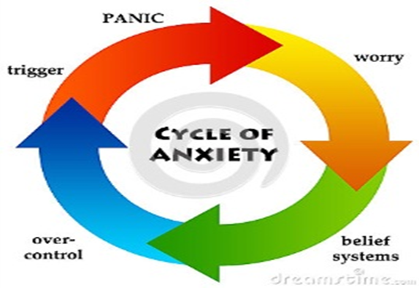
- Ages 13-18 are the most prevalent for generalized anxiety disorder and phobias.
- Anxiety can leave you feeling embarrassed or humiliated.
- You may experience a pounding heart, sweating, shaking, shortness of breath, feelings of choking.
- Children and adolescents with anxiety tend to seek frequent reassurance from caregivers, teachers, and others about their performance, although this reassurance only provides only fleeting relief from their worries.

Parenting Tips and Techniques for Anxiety
Here are things you can do at home to help your child manage his or her anxiety disorder:
- Pay attention to your child’s feelings.
- Stay calm when your child becomes anxious about a situation or event.
- Recognize and praise small accomplishments.
- Don’t punish mistakes or lack of progress.
- Be flexible, but try to maintain a normal routine.
- Modify expectations during stressful periods.
- Plan for transitions (For example, allow extra time in the morning if getting to school is difficult).

Keep in mind that your child’s anxiety disorder diagnosis is not a sign of poor parenting. It may add stress to family life, however. It is helpful to build a support network of relatives and friends. It's important that you have the same expectations of your anxious child that you would of another child.
Self Help Tips to Managing Symptoms of Anxiety

- Take a time out: When feeling anxious allow yourself to take a break and step back from the problem to clear your head. Engage in relaxation activities like exercise, practice yoga, listen to music, meditate, and learn other relaxation techniques suitable for you.
- Eat a well-balanced diet: Do not skip meals. Do keep healthful, energy-boosting snacks on hand.
- Limit alcohol and caffeine: These substances can aggravate anxiety and trigger panic attacks.
- Take deep breaths: When faced with stressful or trigger situations utilize deep breathing to manage anxiety.
- Practice acceptance: Realize that you are not in control of everything and practice putting your stress into perspective. Is the situation really as bad as you think?
- Welcome humor and maintain a positive attitude: Make an effort to replace negative thoughts with positive ones.
- Get involved: Volunteer or find another way to be active in your community, which creates a support network and gives you a break from everyday stress.
- Learn what triggers your anxiety: Is it work, family, school, or something else you can identify? Write in a journal when you are feeling stressed or anxious, and look for a pattern.
- Reach out for support: Talk to friends and family when you are feeling overwhelmed and let them know ways they can help you. Or consult with a physician or therapist for professional help.
Free Mental Health Apps

Anxiety
SAM - Self Help for Anxiety Management
App designed to help people manage physical symptoms of anxiety and depression. (App Store and Google Play)
Mindfulness
Breathe2Relax
Developed for stress management, this app helps reduce stress, stabilize mood, control anger and manage anxiety through breathing exercises. (App Store and Google Play)
Headspace
Meditation made simple. Guided meditations suitable for all levels from Headspace. Meditation can help improve your focus, exercise mindful awareness, relieve anxiety and reduce stress. (App Store and Google Play)
Sleep
Breathe, Think, Do with Sesame
This app is intended for parents and caregivers to use with their young children (ages 2-5) to help teach skills such as problem-solving, self-control, planning, and task persistence. (App Store and Google Play)
Calm
This app is the perfect meditation app for beginners, but also includes hundreds of programs for intermediate and advanced users. Guided meditation sessions are available in lengths of 3, 5, 10, 15, 20 or 25 minutes so you can choose the perfect length to fit with your schedule. (App Store and Google Play)
For more apps, check out this website: http://parentingchaos.com/anxiety-apps-kids/

Progressive Muscle Relaxation
https://www.youtube.com/watch?v=6053dnI4Rxg
Resources and Contacts
- Lakeside
  - 901-377-4700
- Mobile Crisis
  - 855-274-7471
  - 901-577-9400
- Suicide Prevention
  - 800-273-8255
  - 901-274-7477

