Using Virtual EMS

The Cecil C. Humphreys School of Law now has access to the Virtual EMS tool to view events and request spaces through the web. This tool is available to all Memphis Law faculty, staff, and students. Requests made through this system will go to Maria Fuhrmann (<mfuhrmnn@memphis.edu>) for approval. The EMS calendar can be found using the link below, and also on the [On Legal Grounds Information Page](http://www.memphis.edu/law/current-students/blog-information.php) and on the bottom left side of the [Law School homepage](http://www.memphis.edu/law/).

# Logging In

Using your browser, go to <https://emsws-2016.memphis.edu/virtualems/> and enter your University of Memphis user ID and password on the login screen, and then click “Sign In”.

**PLEASE NOTE: YOU MUST MAKE RESERVATIONS USING THE BROWSER ON YOUR DESKTOP. VEMS doesn’t work properly in a mobile browser.**

# Viewing the Calendar for Event Planning

1. Notice the menu items in the left pane. These each correspond to a different feature within the calendar.
   * Home – return to primary EMS menu screen
   * Create a Reservation – begin room reservation process
   * My Events – will display any reservations created by you
     + Cancellations and modifications can be made here
   * Events – displays all events scheduled for that day campus wide in list view
   * Locations – displays all events scheduled for that day in a grid display
   * People – provides a search query to find events by Client Name.
2. When selecting from the “Events” view, make sure to select “Add Filter” in the top right corner of the screen. From the drop down menu chose Locations, and then Downtown Law School Building.
3. When selecting from the “Locations” view, you must apply the filter by clicking “Add/Remove Locations,” and then choosing Downtown Law School Building.

You can use either the “Events” or “Locations” view to search for an available room in the EMS system.

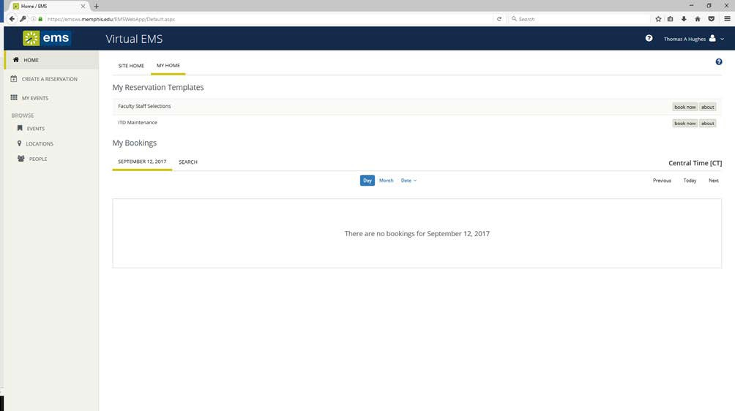Make sure the location filter is applied. If you want a list of events at the Law School, make sure to use the “Events” view. If you want events to appear in a grid format then use the “Locations” view. The “Locations” view is easier to search for an open room, because it is viewed as a grid and not a list.

**HOW TO SCHEDULE AN EVENT USING THE VIRTUAL EMS WEB TOOL**

Virtual EMS (vEMS) is used to request event space at the University of Memphis School of Law by internal clients. It is accessible to all Memphis Law faculty, staff, and students.

1. Navigate to <https://emsws-2016.memphis.edu/virtualems/> . ***Note that*** ***vEMS is not compatible with Mozilla/Firefox.***Under the My Home tab, sign in with your Memphis username and password.
2. Click Book Now next to Law Students.
3. Start with the “Date & Time” section:
   1. Under “Date,” click the calendar to select a single date for your event. Next, enter the event start and end time. **It is important that the actual start and end time is entered.** EMS will automatically include **at least one hour** for setup and teardown.
   2. 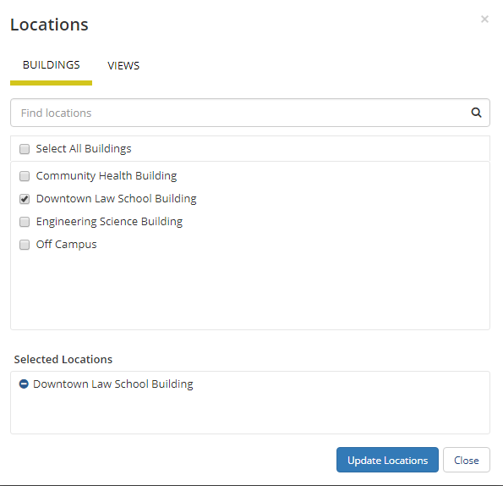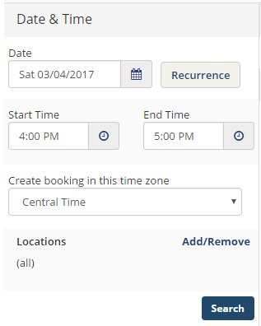Next to “Locations,” click Add/Remove and select the "Downtown Law School Building." "Downton Law School Building" should appear as your selected location.
   3. You can now select your room, either by using the “Let Me Search for Room” options or by choosing “I Know What Room I Want” option.
      1. For the “Let Me Search for Room” option, Follow the prompts and then click the “search” button. All your available rooms will show up for selection.
      2. For the “I Know What Room I Want” option simply type in the desired room, and select it from the drop down menu.
   4. For a single event date, you’ll see a **schedule** of available (and unavailable) rooms you can request. The event start and end time will be between two red lines. To get more information about a particular room, click on the room name in **blue lettering**. Select the room(s) that meets your setup/attendance requirements by clicking the blue plus (+) sign.

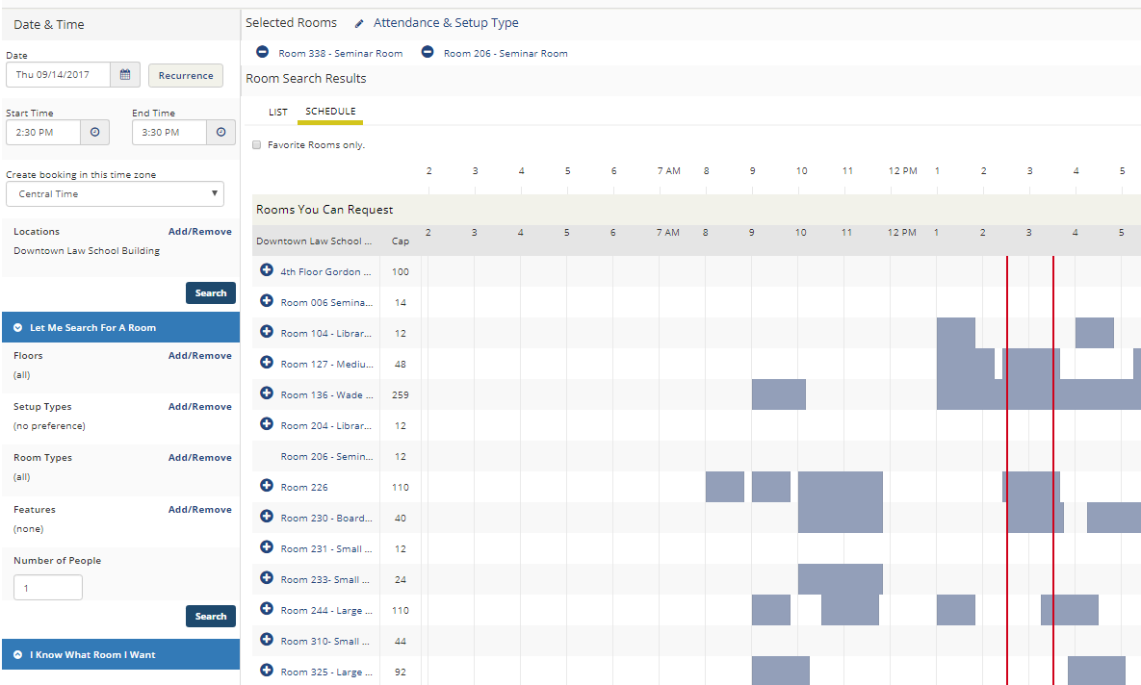

* 1. After you select the plus sign, a popup box will appear asking you for information about the number of attendees and the set-up type. Each room has different options for Setup Type, but you should always pick “Existing Set.” Click “Add Room” to move to the next step.

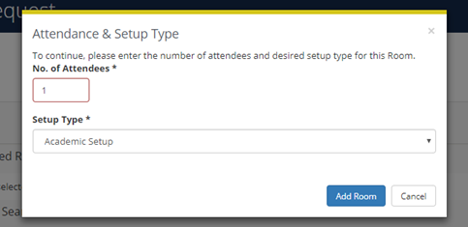

* + 1. If you need a different setup, you should still select “Existing Set” and then contact Maria Fuhrmann (<mfuhrmnn@memphis.edu>) if you need a work order to move furniture. (Hint: you need a work order if the room needs to be rearranged at all).

1. Your choice(s) will move to the Selected Rooms portion toward the top of the page. Simply click the minus sign (-) to remove the room.
2. Once you have your selected room(s), click “Next Step” toward the top of the page to continue.
3. The next step includes adding services to your room reservation request. Do not add any services to this section of the reservation.
   1. If you need Audio/Visual services for your event email Andrew Hughes at [tahughes@memphis.edu](mailto:tahughes@memphis.edu) as far in advanced as possible, with a reminder 2 – 3 days before the event. Please be as detailed as possible in your email, and include the day, time, room, and any A/V needs.
   2. Inputting A/V services into the EMS system (on the Service for Your Reservation page) will not alert IT of your reservation, so please reach out to IT directly using the email above.
4. The third and final step in the reservation process is the Reservation Details. Fill in each field as necessary.
   1. Event Name: Enter a name for your event
      1. Use a name that will be descriptive for your event so that people looking at the calendar will know what the event is.
   2. **Select “*Law School Student Activities”* as the Event Type**

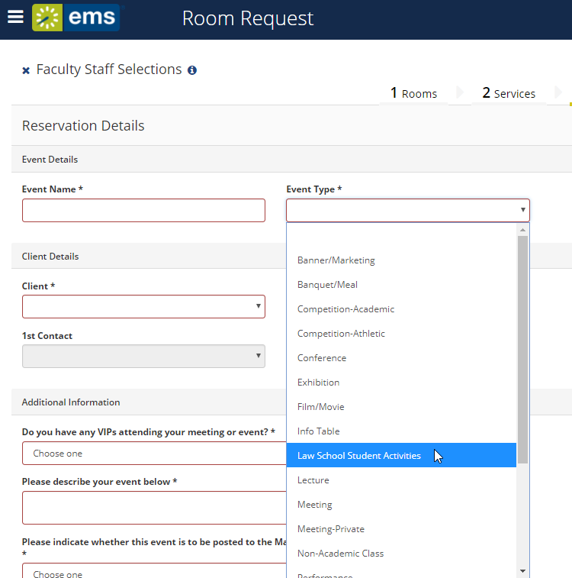

* 1. **Select your student organization name as the Client Type.** 
     1. **You can do this by searching “UofM Law School” followed by your student organization’s name. For example, “UofM Law School Student Bar Association.”**
     2. **If your student organization is not listed, it means you have not completed the RSO registration process in TigerZone. This is required. You must complete the full process including designating (and having your invitation accepted) for your advisor and scheduler. You can find information about registration** [**here**](http://www.memphis.edu/law/student-affairs/student-organizations-info.php)**.**
  2. **Select YES under the option to publish to the Master Calendar under “Additional Information” unless yours is a private event.**

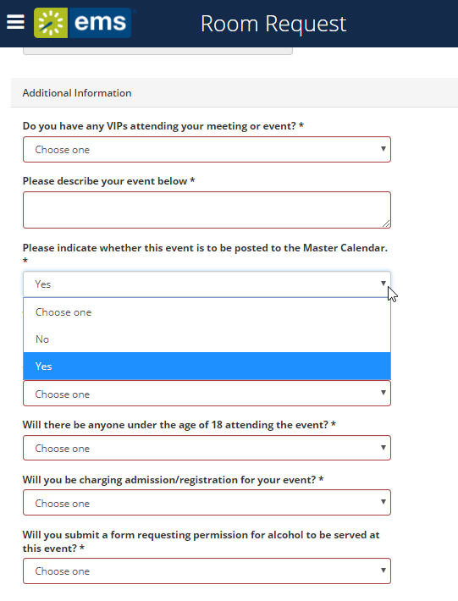

* 1. **To not display your event on the Law School Students Calendar**

**Select NO under the option to publish to the Master Calendar under “Additional Information.”**

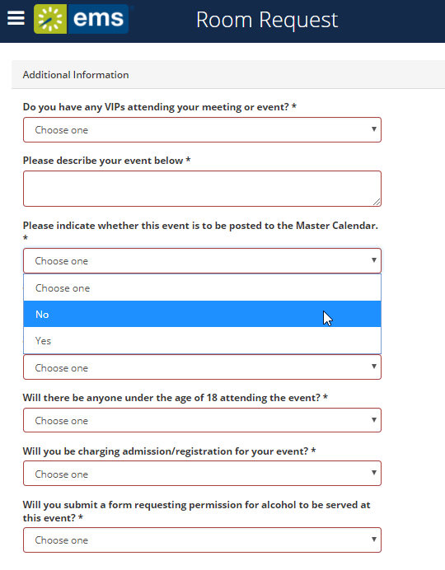

* 1. Client Details: **All law school student organizations will begin with “UofM Law.”** In the search box, type “UofM Law”. The system will begin to auto-filter results as you type. The name of your student organization should appear on the list, and you should select that as your Client. Once the client name has been selected, it will add it as a client you can book for. Close the pop-up window and select the client name from the dropdown.
     1. If you do not see your name listed from the contact dropdown, please contact the Scheduling Office at (901) 678-2042, to be added to the Client list.
     2. Whoever is making the reservation should be selected as the First Contact from the dropdown. The Second Contact is optional for University departments, but **the Faculty/Staff advisor must be listed as the Second Contact for all Registered Student Organizations**.
  2. Additional Information:
     1. If your VIP isn’t listed from the dropdown or you have more than one VIP attending, select “Other/Multiple” and list them in your event description.
     2. **If you have any VIP guests, Maria Fuhrmann, Dean Strickland’s Assistant, needs to be notified immediately.**

1. Submitting your request: After submitting your request, you will receive an email notification of your reservation request. **This is not a confirmation**. Once your booking is approved, you will receive a reservation confirmation email from Ann Onidas.