ARE YOU INTERESTED IN
Education Reading & Writing Cognitive Science Psychology

JOIN OUR LAB!
We conduct cognitive and educational research on reading and writing using computerized games and strategies.

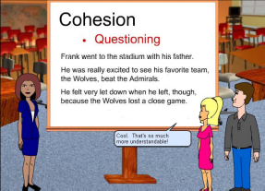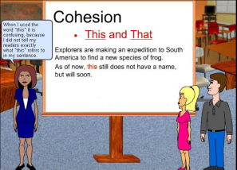

Members of our lab who are motivated and have a positive attitude have received:

- Excellent letters of recommendation for jobs or graduate school
- Invaluable research experience aimed at developing better learning and teaching skills for people of all ages.
- Hands-on training in a cognitive science lab
- Connections to other students, graduate students, and faculty
- 1 to 6 hours of class credit in Psych 4503 or 3 credits in 4504

Join NOW and your responsibilities may include:

- Assisting in collecting, organizing, and/or analyzing data
- Helping design studies
- Writing and obtaining reviews for human subjects (IRB)
- Presenting at conferences and lab group meetings.
No previous experience is necessary! EMAIL NOW:
Mary Jane White white10@memphis.edu


